**First Person Shooter games: Top 10**

First Person Shooter gaming genre is an emerging one with millions of fans across the globe. These games provide exciting shooting and fighting experience with a series of features embedded for adventurous experiences. These games are highly engaging and have been proven to be addictive for a lot of youngsters worldwide. These games are the higher revenue generators with various tournaments and events to ensure higher engagement.

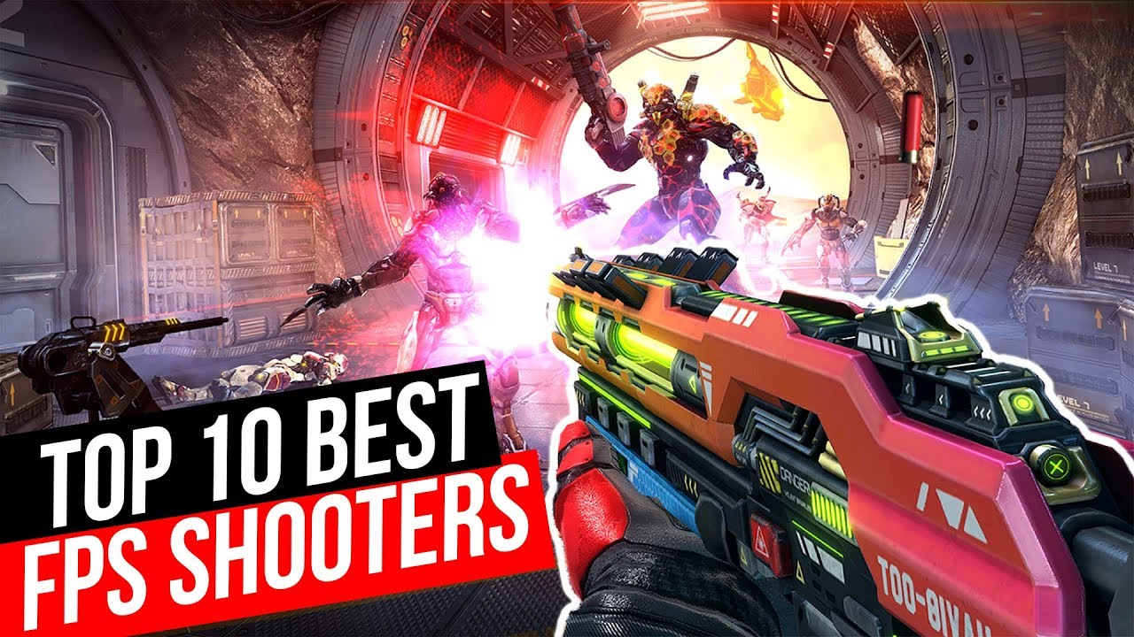

These games come in various types from team building and surviving to capture the flag and winning the prize amounts. Eventually, survival is the main key to have winning in these games.

First-person Shooter games are the complete entertainment and excitement packages and have a lot of features to be uncovered with game-play experiences. Here are the top 10 First-person shooter games that are the best ones in the market and have gained millions of fans in the past years.

**Call of Duty: Mobile**

Call of Duty is the best-seller game for almost a decade now. From PC based games to mobile games, CoD has marked its territory with exciting features that it offers to its players. Cod Mobile has a multiplayer gaming option embedded in the FPS techniques that helps to compete with friends as well as strangers. Apart from various gaming modes, a 100 player Battle Royale is available too with CoD. This game is free to play availability with cash and reward prizes to be won. The game also has in-app purchases for enhanced experiences that any pro-gamer might want.

**PUBG Mobile**

PUBG mobile provides the best gameplay experiences to both Android as well as iOS users with shooting and battle-field experiences that are embedded in it.

There is a Battle Royale with 100 players who fight against each other to reach the end and win the prizes and enjoy virtual chicken dinner. Players can play in squads too to enhance the experiences. This is a free game but has some premium memberships that provide extra rewards to the players. Every 6-8 weeks, there is a new game release with a new tournament to keep the gamers engaged.

**Critical Ops**

Critical Ops is an admirable first-person shooter game with 3 gaming modes provide that is a team deathmatch, bomb defuse, and gun game. It has millions of daily players that ensure perfect competitions in no wait time and with every killing, the game provides a new set of weapons in the accessibility. This is a free gaming platform that has a few in-app purchases to have access to the newest skins and weapons. This gaming technique is fast-paced and has a simple interface to start new games with ease.

**Modern Combat 5**

This is one of the most famous First Person Shooter games that was released in 2-009 for the first tim11e, and since that it had experienced fruitful success results. Modern Combat is now with its 5th edition from Gameloft. The game revolves around the special members who have to wipe away all the terrorists and make a safe environment. This game is about the special force that the player is a part of. This game has attractive features and gaming interfaces and provides a multiplayer online gaming service too.

**World War Heroes: WW2**

As the name suggests, the game is about the heroes and soldiers of the world war era. This game is comparatively new, and it was released in August 2017. World War Heroes is a gaming experience where the players stay as the fighters of that time and have to pass various levels and battlefields, and survive to maintain their glory. This is the best game to have a soldier like experience along with the first-person shooter genre.

**Shadowgun Legends**

This is an exciting game for the First-person shooter genre and has exciting features along with an attractive and adventurous interface. This game is based on science fiction and is available for playing over mobile devices. The game has 2 gaming modes that are 4v4 battle as well as the story campaign. This game developed by Madfinger lacks in any loophole. The game is selected by many gamers because of the detailing it has in its interface, storyline, and sound quality for immense pleasure.

**Battle Prime**

This is an amazing multiplayer first-person shooter game that is faster than most of the FPS games. The game has 8 agents that can be unlocked and transformed into the playing character, and each agent has its different specialties. Battle Prime has several maps and gaming modes available, and people can play in teams and fight the enemies marked red on the map. The game also supports a premium subscription that provides access to extra features. With the movable and interactive features, this game is widely recommended and has a giant fan base.

**Hitman: Sniper**

In this game, the player needs to act as Agent 47 and has a rifle and is surrounded by riches, bodyguards, and enemies in a building. The player here needs to strategically decide every move and start killing the enemies with every chance. The game has various missions, and winning these provides the rewards that can be used for upgrades. This game has amazing graphics and controls, and the players need to be ready for any enemy actions. The game has an interactive interface with an exciting and energetic sound that ensures enhanced experiences.

**Fortnite**

This is a Battle Royale that is free to play and has experienced success from the Play Store availability that it offers. It revolves around the gaming technique in which a hundred players Revolt against each other, and the individual or the squad that is left at last is the winner. It has a huge map that shrinks with time, and this game is easily accessible to all the players. Fortnite also has micro-transactions available for reward distributions, and there is a paid version available too with enhanced gaming experiences through certain series and sessions.

**Dead Trigger 2**

Dead Trigger 2 is one of the famous First-person Shooter games that have acquired its success with various gaming techniques with enhanced entertainment that it offers to the players. This is a Zombie shooting experience and there are various references and virtual experiences to enhance entertainment. The game also offers easy interface and controls that just need some movements to target a zombie and fire, and you have to survive to be the last winner. Various adventures are added on with in-app purchases to add on to the pleasure that Dead Trigger 2 offers.

